**SDM COLLEGE OF ENGINEERING AND**

**TECHNOLOGY DHAVALAGIRI, DHARWAD**

**580002**

(**An autonomous Institution affiliated to**

**Visvesvaraya Technological University, Belagavi - 590018**)

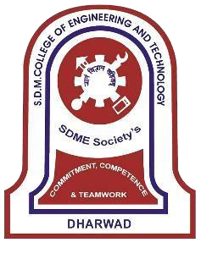

# Department of Information Science and Engineering

**5TH SEMESTER B.E ACADEMIC YEAR: 2023-24 MINOR PROJECT-1**

**21UISL505 “RAKTDAAN ANDROID PROJECT’’**

**Under the guidance of**

**Dr. Jagadeesh Pujari**

**SUBMITTED BY,**

**Project ID: 9**

**Semester: V**

**CHINMAY MAGI**    **2SD21IS013**

**SOHAN MUKHTEDAR 2SD21IS048**

**VISHAL K SAKLATHI 2SD21IS061**

**SDM COLLEGE OF ENGINEERING AND**

**TECHNOLOGY DHAVALAGIRI, DHARWAD**

**580002**

**(An autonomous Institution affiliated to**

**Visvesvaraya Technological University, Belagavi - 590018)**



# Department of Information Science and Engineering

**CERTIFICATE**

This is to certify that Mr Chinmay Magi (2SD21IS013), Mr Sohan Mukhtedar (2SD21IS048), Mr Vishal Krishnamurti Saklathi (2SD21IS061), Student of 5th Semester have satisfactorily completed the Minor Project -I entitled **“Raktdaan Android Project”** at Department of Information Science and Engineering, SDM College of Engineering and Technology, Dharwad – 580002.

**Dr Jagadeesh Pujari Dr Varsha Jadhav Dr Jagadeesh Pujari Dr K. Gopinath**

**Project Guide Project Coordinator HoD. of ISE Principal**

**SDMCET, Dharwad**

**TABLE OF CONTENTS**

**ACKNOWLEDGEMENT**

**ABSTRACT**

**LIST OF FIGURES**

**CHAPTER 1 INTRODUCTION**

1.1 INTRODUCTION OF PROJECT…………………………………….……………..01

1.2 PURPOSE ……………………………………………………………….………….01

1.3 SCOPE……………………………………………...…………………….……........02

1.4 PROBLEM DEFINITION………………………………………….……………….02

1.5 OBJECTIVES………………………………………………………….………........02

1.6 METHODOLOGY......................................................................................................03

## 1.7 LIMITATIONS…………………………………………………………...……........03

**CHAPTER 2 TECHNOLOGIES USED**

**CHAPTER 3 SOFTWARE REQUIREMENT SPECIFICATION**

3.1 PRODUCT PERSPECTIVE.......................................................................................06

3.2 PRODUCT FUNCTIONS ………………………………………..…………………15

3.3 USER CHARACTERISTICS…………………………………..………...……........17

3.4 CONSTRAINTS……………………………………………..………..…………….19

3.5 ASSUMPTION AND DEPENDENCIES …………………………………….……..20

3.6 APPORTIONING OF REQUIREMENTS………………………………..….………21

**CHAPTER 4 SPECIFIC REQUIREMENTS**

4.1 EXTERNAL INTERFACES…………………………………………….…………24

4.2 FUNCTIONS …………………………………………………………………25

4.3 DESIGN CONSTRAINTS…………………………………………………..……..26

4.4 LOGICAL DATABASE REQUIREMENTS…………………………..………......26

4.5 DESIGN CONSTRAINTS…………………………………………………..……..27

4.6 SOFTWARE SYSTEM ATTRIBUTES………………………………………….....28

## 4.7 ORGANIZING SPECIFIC REQUIREMENTS………………………………….....29

**CHAPTER 5 CHANGE MANAGEMENT PROCESS**

**CHAPTER 6 DESIGN PHASE**

6.1 ARCHITECTURAL DESIGN…………………………………………………...34

6.2 DATA FLOW DESIGN…………………………………………………………..34

6.3 CLASS DESIGN………………………………………………………………...36

6.4 USECASE DESIGN……………………………………………………………..37

6.5 SEQUENCE DESIGN…………………………………………………………....38

**CHAPTER 7 IMPEMENTATION PHASE**

7.1 EXPERIMENTAL SETUP………………………...………..……………….…..39

7.2 PSEUDO CODE…………………………………………………………………40

**CHAPTER 8 TESTING PHASE**

## 8.1 TYPES OF TESTS CARRIED OUT………………………………………...42

**CHAPTER 9 RESULTS AND DISCUSSIONS**

**CHAPTER 10 APPLICATIONS**

**CHAPTER 11 CONCLUSION**

**REFERENCES**

## ACKNOWLEDGEMENT

The sense of contentment and elation that accompanies the successful completion of our task would be incomplete without mentioning the names of the people who helped in accomplishment of this project, whose constant guidance, support and encouragement

resulted in its realization.

We talk this opportunity to thank our principal, Dr. K. Gopinath for providing us with sense and healthy environment within college, which helped us in concentrating on our task.

We express our deep sense of gratitude to our Head. Department of Information Science and Engineering, Dr. JAGADEESH PUJARI for providing us the necessary facilities for conducting the demonstration and extending cooperation.

We are also grateful to Dr. JAGADEESH PUJARI for his valuable guidance and encouragement. We are also thankful to our project coordinator Prof. VARSHA JADAV for smoothful coordination.

Lastly we are very much indebted our parents and friends for their unquestioning cooperation and help.

i

## ABSTRACT

The "Raktdaan" Blood Donation App is a mobile application designed to revolutionize the way blood donation and distribution occur in our society. With the aim of addressing critical blood shortage challenges, "Raktdaan" connects blood donors, recipients, and blood banks seamlessly, promoting a culture of regular blood donation and saving countless lives. "Raktdaan" leverages location-based technology to connect blood donors with recipients in need within their proximity, facilitating faster and more effective blood donation drive. With user-friendly features such as donor registration, real-time blood requests, hospital and blood bank integration, appointment scheduling, education and awareness along with privacy and security, “Raktdaan” aims to cultivate a strong and engaged community of donors, making blood donation a simple, convenient, and life-saving experience for all.

ii

## LIST OF FIGURES

**CHAPTER 3**

Architecture model………………………………Fig 3.1

### **CHAPTER 6**

Architectural Design……………………………..Fig 6.1

Data Flow Design………………………………..Fig 6.2 Class Design……………………………………..Fig 6.3

Use Case Design…………………………………Fig 6.4

Sequence Design…………………………………Fig 6.5

### **CHAPTER 9**

Results……………………………………………Fig 9.1-9.6

iii

**CHAPTER 1**

## INTRODUCTION

### 1.1 Introduction

Blood donation is a process where a person donates blood voluntarily to save a person’s life in critical condition or a blood bank. In a world where medical emergencies and surgeries are an everyday occurrence, access to a stable and readily available blood supply is critical. Hence, we came up with an innovative idea of blood donation app ‘Raktdaan’ which encourages, engages and motivates potential and existing donors. The platform needed to make the donation process more convenient and the experience more rewarding. This innovative mobile application seeks to bridge the gap between potential donors and patients in dire need of blood, making the process of blood donation more accessible and convenient than ever before. With its user interface, geolocation features, rewarding donations our project poised to bring about a typical example in the way we approach and participate in lifesaving blood donations.

Nowadays, several blood apps are accessible in play store, however their utilization is extremely poor owing to disadvantage of privacy and safety. Donor Contacts may be simply accessed by everybody. All apps that are accessible focuses the property between the donors and therefore, the recipient at fewer intervals. Our project was created to protect the donor's privacy and donor identity, as well as the recipient's safety. The proposed solution attempts to provide support for both emergencies and reserved time things. This mobile application, centralised for blood donation, allows NGOs and Hospitals to find blood donors in their neighbourhood. All information on the blood donor details will be included in the application. Our application allows authorised users to create request on the status of donor for blood donations in the nearby area.

Our project aims to develop a user-friendly and efficient mobile application for blood donors and recipients. Our project is built using Android Studio platform, Flutter for frontend framework, MongoDB as database.

### 1.2 Purpose

‘Raktdaan’ is an innovative mobile application designed to revolutionize blood donation by connecting potential donors and recipients efficiently. Its primary goal is to make the blood donation process more accessible, convenient, and rewarding. By prioritizing donor privacy and recipient safety, the app ensures secure communication while incentivizing regular donations. With a user-friendly interface and donor search features, it bridges the gap between donors and patients in need of blood, enabling quick and easy connections in both emergency situations and planned donation drives. Ultimately, ‘Raktdaan’ serves as a centralized platform for blood donation, streamlining the process for NGOs and hospitals to locate nearby donors and fulfil critical blood needs.

### 1.3 Scope

The ‘Raktdaan’ Blood Donation app aims to streamline the blood donation process and promote awareness. Users can register and create profiles, providing critical medical information. The app facilitates the search for donors based on location, blood type, and availability, with advanced filters for specific needs. Recipients can submit blood requests, triggering notifications to eligible donors. Donors can view and respond to requests in real time, and detailed profiles showcase donors' history and reliability. The app also includes a Blood Facts section, offering educational content on blood donation. An admin panel ensures user management, analytics, and emergency broadcasts for urgent needs. Security and privacy are prioritized, with robust encryption and privacy controls. Push notifications keep users informed, and compatibility across platforms ensures accessibility. Rigorous testing, reporting mechanisms, and future enhancements, such as health record integration and gamification, further enhance the app's functionality. ‘Raktdaan’ aspires to revolutionize blood donation, making it more efficient, accessible, and impactful for both donors and recipients.

### 1.4 Problem definition

The existing blood donation system faces significant challenges in efficiently connecting donors with recipients, resulting in critical shortages during emergencies and an inefficient utilization of available blood sources. Our project aims to address these issues by developing the "Raktdaan" app, which seeks to revolutionize the way blood donation is conducted, making it more accessible, organized, and responsive to the ever-present demand for blood.

### 1.5 OBJECTIVES

* To enable users to register as blood donors, providing their contact information, blood type, and eligibility details.
* To let donors to schedule appointments for blood donations, reducing wait times and streamlining the donation process.
* To provide a feature for hospitals and individuals to send out emergency blood requests, allowing users to respond quickly.
* Ensuring screening of user’s eligibility to donate blood based on factors like recent donations, medical history, and travel & recent activities.
* To Improve the availability of blood for medical emergencies, strengthen community engagement in blood donation, and enhance the overall efficiency of blood management.
* To Achieve a user-friendly interface, increase the number of registered donors, and establish a robust communication network for prompt blood-related coordination

### 1.6 PROPOSED METHODOLOGY

The methodology for our project will focus on efficiency and rapid development to meet the objectives of creating a user-friendly and functional app for connecting donors with recipients while promoting blood donation awareness. Our methodology begins with extensive requirements gathering, delving into the specific needs of blood donors, recipients, and healthcare organizations. In terms of technology, we employ Java and Kotlin for frontend development, creating a visually appealing and user-friendly interface. On the backend, we set up a robust infrastructure consisting of servers, databases, and APIs. We prioritize data security. Geolocation integration is a pivotal feature, allowing users to find nearby blood donation opportunities, blood banks, and hospitals in need of blood. A sophisticated donor matching algorithm is at the heart of the app, connecting donors with recipients based on factors like location, blood type compatibility, and the urgency of need. Ongoing user feedback, data analysis, and regular updates are prioritized to enhance functionality, security, and user experience.

It includes three modules

1.Request for Blood

* The module contains various input credentials like patient ‘s first name, blood group required, units, required date, contact number, Hospital name, location and additional comment for potential donors.
* Once all the credentials are filled, then we have agreed for terms and conditions, then after requesting information will be sent to database.

2.View Requests

* The module contains all the requests for blood with some functions like share, message etc.
* Among the requests the one that is critical is on the top most of the list.

3. Search Donors

* The module contains filters for blood group, locations. Once a particular blood group is selected and locations are to be selected.
* Once the search operation begins blood donors list will be displayed which contains call options.

#### 1.7 Limitations

Some of the main limitations of the project are as follows:

The system does not support languages other than English language.

The database has location details limited only to Karnataka.

Though donor locations can be specified, it lacks connection to real time Geo-locatio

**CHAPTER 2**

## TECHNOLOGIES USED



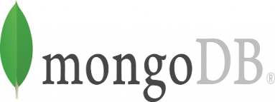

2.1 2.2 2.3

### Android Studio

Android Studio is the official IDE for Android app development, based on IntelliJ IDE Android Studio is equipped with several features that by streamline the overall app development process.

To develop our project, we felt used Android Studio is the convenient platform.

Flutter

Flutter is an open-source UI software development kit created by Google. It is used to develop cross platform applications from a single codebase for any web browser.

The basic component in a Flutter program is a "widget", which can in turn consist of other widgets. We have used flutter for the front-end purpose.

MongoDB

MongoDB Atlas is a multi-cloud database service by the same people that build MongoDB. Atlas simplifies deploying and managing your databases while offering the versatility you need to build resilient and performant global applications on the cloud providers of your choice. It involves following features :

Deploy a Database, manage database Users, Customize your Database Deployment, Configure Private Network Access, Add IP Access List Entries. Since Blood donation app requires huge amount of donors and requests data we choose this cloud platform.

**CHAPTER 3**

## SOFTWARE REQUIREMENT SPECIFICATION

**The Overall Description**

Overall Description of the ‘Raktdaan’ Android App:

The ‘Raktdaan’ Android app represents a cutting-edge solution at the intersection of healthcare and technology, aiming to streamline and optimize blood management processes. This section provides a comprehensive overview of the factors influencing the development of the Raktdaan app, offering insights into its purpose, functionality, and potential impact.

1. Product Perspective: The Raktdaan app exists as a standalone product designed to operate on Android devices. It interfaces with external systems for location services, messaging, and potentially, a central blood bank database. As a user-centric application, it serves as a bridge between blood donors, recipients, and healthcare professionals, enhancing communication and coordination.
2. Functionality: The primary functionalities of the Raktdaan app include user registration, blood donation event coordination, blood request management, real-time communication, and donor recognition. The app prioritizes user experience, ensuring a seamless interface for intuitive interactions.
3. User Characteristics: The target users encompass a diverse range, including potential blood donors, recipients in need of blood, and healthcare providers managing blood-related activities. The app accommodates users with varying levels of technological proficiency, promoting inclusivity and accessibility.
4. Constraints: The development of the Raktdaan app is subject to constraints such as technological limitations, compliance with data protection regulations, and potential dependencies on external services. These constraints are carefully considered to ensure the app's functionality aligns with ethical and legal standards.
5. Assumptions and Dependencies: Certain assumptions, such as the availability of reliable internet connectivity and GPS services, are integral to the Raktdaan app's functionality. Dependencies on external services, like messaging platforms, are also acknowledged and managed to ensure seamless integration.
6. Goals and Objectives: The overarching goal of the Raktdaan app is to contribute to efficient blood management by fostering a community of engaged donors, facilitating timely donations, and enhancing communication within the blood donation ecosystem. The objectives include improving the availability of blood during emergencies, increasing donor participation, and creating a user-friendly and impactful platform.

By providing this overall description, the Raktdaan Android app project sets the stage for a more detailed and technical exploration of requirements in Section 3, facilitating a comprehensive understanding for both customers and developers.

### 3.1 Product Perspective

The ‘Raktdaan’ Android app is designed as an independent and self-contained product focused on revolutionizing blood management processes. It operates as a standalone system with no direct dependencies on external software, ensuring its autonomy and ease of integration into diverse environments. As a user-centric application, Raktdaan serves as a comprehensive solution, connecting blood donors, recipients, and healthcare professionals within a singular platform.

Interaction with External Systems:

* Location Services: The Raktdaan app interacts with the device's location services to provide real-time information about nearby blood donation events and facilitate efficient coordination.
* Messaging Platforms: For seamless communication, the app may integrate with external messaging services to enable real-time interaction between users.

Comparisons to Other Systems:

* Marketplace Position: Raktdaan stands out in the marketplace as a purpose-built Android app solely dedicated to blood management. While other health-related applications may exist, Raktdaan uniquely focuses on fostering a community of blood donors and recipients.
* Differentiators: Unlike generic health apps, Raktdaan's primary differentiators lie in its specialization in blood donation coordination, real-time communication, and donor recognition.

Block Diagram:

* User Interface: The app presents a user-friendly interface allowing donors to find events, healthcare providers to manage blood requests, and recipients to communicate with potential donors.
* Database Management: A secure database system manages user profiles, events, and communication logs, ensuring data integrity and privacy.
* External Interfaces: Interfaces with the device's GPS for location-based services and potentially integrates with external messaging platforms for efficient communication.

This block diagram depicts the major components of Raktdaan's larger system, emphasizing its independence while showcasing essential interactions. The app is presented as a black box, highlighting its role in facilitating blood management without delving into internal architecture details. The design document will further elaborate on the app's internals and technical specifications.

#### 3.1.1 System Interfaces

System Interfaces for Raktdaan Android App:

1. Location Services:

* Functionality: The Raktdaan app interacts with the device's location services to provide users with information about nearby blood donation events and relevant healthcare facilities.
* Interface Description: Utilizing Android Location APIs, the app accesses the device's GPS functionality to retrieve real-time location data. This interface ensures accurate event recommendations based on the user's geographical position.

2. Messaging Platforms:

* Functionality: To facilitate real-time communication between blood donors, recipients, and healthcare professionals, the Raktdaan app may integrate with external messaging platforms.
* Interface Description: The app would utilize APIs or SDKs from messaging services (e.g., Firebase Cloud Messaging) to send and receive messages. This integration ensures efficient and immediate communication within the Raktdaan community.

3. External Database Management System:

* Functionality: Raktdaan manages user profiles, blood donation events, and communication logs through a secure database system.
* Interface Description: The app interfaces with an external Database Management System (DBMS), possibly utilizing APIs like SQLite for local storage on the device or a cloudbased solution like Firebase Realtime Database for synchronized data across users.

4. Event Management System:

* Functionality: To coordinate blood donation events, Raktdaan may interact with external systems managing event logistics and schedules.
* Interface Description: The app could use APIs or web services to connect with an Event Management System, allowing for the retrieval and updating of event details, ensuring accurate and up-to-date information for users.

These system interfaces are crucial for Raktdaan's seamless operation, ensuring accurate location-based services, real-time communication, secure data management, and synchronized event coordination. The specifications of these interfaces guide the development team in integrating external systems with the Raktdaan Android app effectively.

#### 3.1.2 Interfaces

Interfaces for Raktdaan Android App Development:

1. Graphical User Interface (GUI):

* Logical Characteristics: Raktdaan employs an intuitive and user-friendly GUI, featuring a clean design with easily navigable menus. It incorporates visual elements such as buttons, icons, and interactive screens to facilitate seamless user interactions.
* Optimization Aspects: The GUI is optimized for user accessibility and engagement, ensuring a straightforward and efficient experience. Consideration is given to font size, color contrast, and interactive elements to enhance usability. ADA compliance is a priority, ensuring inclusivity for users with disabilities through features such as screen reader compatibility and voice command options.

2. Event Coordination Interface:

* Logical Characteristics: Users can coordinate and participate in blood donation events through a dedicated interface. This includes features for event discovery, registration, and real-time updates.
* Optimization Aspects: The event coordination interface is optimized for quick event discovery, with features like filters based on location and event type. ADA compliance ensures that users with varying abilities can seamlessly navigate and participate in events.

3. Communication Interface:

* Logical Characteristics: Raktdaan incorporates a messaging interface for real-time communication between donors, recipients, and healthcare professionals. This includes individual and group messaging features.
* Optimization Aspects: The communication interface is optimized for simplicity and responsiveness, with features like push notifications for immediate updates. ADA compliance is considered, allowing users with disabilities to effectively use and engage with the messaging system.

4. User Registration and Profile Interface:

* Logical Characteristics: Users interact with an interface for creating profiles, managing personal information, and tracking their blood donation history.
* Optimization Aspects: The registration and profile interface is optimized for ease of use during onboarding, featuring clear instructions and accessible form fields. ADA compliance ensures that users with disabilities can complete the registration process without barriers.

5. Accessibility Features:

* Logical Characteristics: Raktdaan incorporates accessibility features to ensure an inclusive experience for all users.
* Optimization Aspects: This includes adjustable font sizes, high color contrast, and voice command options. The app is designed to comply with ADA standards, catering to users with different abilities and providing a universally accessible interface.

#### 3.1.3 Hardware Interfaces

Hardware Interfaces for Raktdaan Android App Development:

The Raktdaan Android app primarily relies on the hardware components inherent to Android devices, and it does not have direct control or interaction with external hardware devices.

As such, there are no specific hardware interfaces required for the functioning of the Raktdaan app. The app operates within the standard configurations and capabilities of Android smartphones and tablets.

Device Compatibility:

* Logical Characteristics: The app is designed to be compatible with a range of Android devices, ensuring flexibility and accessibility for a broad user base.
* Configuration Characteristics: Raktdaan is optimized to function seamlessly across various screen sizes, resolutions, and hardware specifications commonly found in Android devices.

Connectivity Protocols:

* Logical Characteristics: The app relies on standard connectivity protocols inherent to Android devices, such as Wi-Fi, mobile data, and Bluetooth for specific functionalities.
* Configuration Characteristics: Raktdaan is configured to adapt to different network environments, ensuring efficient communication and data exchange without imposing specific connectivity requirements.

Hardware Features:

* Logical Characteristics: Raktdaan utilizes certain hardware features, such as GPS, for location-based services to enhance the user experience.
* Configuration Characteristics: The app is configured to access and utilize the device's GPS functionality to provide accurate location information for event recommendations.

Protocols for Data Transfer:

* Logical Characteristics: Data transfer within the app relies on standard Android protocols for secure communication.
* Configuration Characteristics: Raktdaan ensures the use of secure protocols for data transmission, prioritizing user privacy and the integrity of information shared within the app.

#### 3.1.3 Software Interfaces

Software Interfaces for Raktdaan Android App Development:

The Raktdaan Android app interfaces with several software components to enhance its functionality and provide a seamless user experience.

The Raktdaan Android app interfaces with several software components to enhance its functionality and provide a seamless user experience.

1. Android Studio
2. Flutter
3. MongoDB
   1. Name: MongoDB
   2. Mnemonic: N/A
   3. Specification Number: N/A
   4. Version Number: Latest stable version (e.g., MongoDB 5.0)
   5. Source: Official MongoDB website ([*https://www.mongodb.com/*)](https://www.mongodb.com/)

Interfaces

1. Interface with MongoDB for Data Storage

1. Purpose: MongoDB serves as the primary database system for storing and managing data related to donor registrations, donation history, and blood requests within the Blood Donation App.
2. Message Content and Format: Communication with MongoDB occurs using MongoDB's native query language and data format, primarily JSON (JavaScript Object Notation). The interface involves CRUD (Create, Read, Update, Delete) operations for managing donor records, donation information, and blood request details.

#### 3.1.4 Communications Interfaces

Communications Interfaces for Raktdaan Android App Development:

In the development of the Raktdaan Android app, various communication interfaces are integral for enabling smooth interactions and data exchange. These interfaces encompass both local network protocols and standard communication methods.

1. HTTP/HTTPS Protocol:

- Description: Raktdaan utilizes the HTTP/HTTPS protocols for communication with external servers and services. HTTP is employed for general data exchange, while HTTPS ensures secure and encrypted communication, safeguarding user data and information during transactions.

2. Firebase Cloud Messaging (FCM):

- Description: FCM serves as a crucial communication interface for real-time messaging between Raktdaan users. It enables the delivery of push notifications, ensuring prompt communication regarding events, messages, and updates.

3. Location-Based Services (GPS):

- Description: The app leverages the device's GPS capabilities for location-based services. This communication interface allows Raktdaan to access accurate geographic coordinates, facilitating event recommendations and user positioning.

4. Firebase Realtime Database Communication:

- Description: Raktdaan communicates with Firebase Realtime Database for cloud-based storage and synchronized data access. This interface involves sending and receiving JSON-formatted data to maintain consistency across users and devices.

5. Local Database Interaction (SQLite):

- Description: The app communicates with the local SQLite database for efficient storage and retrieval of user profiles, event data, and communication logs. SQL queries are used for interacting with the database, supporting offline functionality.

6. Device-to-Device Communication (Bluetooth - Optional):

- Description: As an optional feature, Raktdaan may incorporate Bluetooth for direct device-to-device communication. This interface allows users in close proximity to exchange information without relying on network connectivity.

These communication interfaces play a vital role in the functionality of Raktdaan, facilitating data exchange, real-time messaging, and location-based services. By leveraging these protocols, the app ensures a responsive and interactive user experience while maintaining the security and integrity of transmitted information.

#### 3.1.6 Architectural Designs

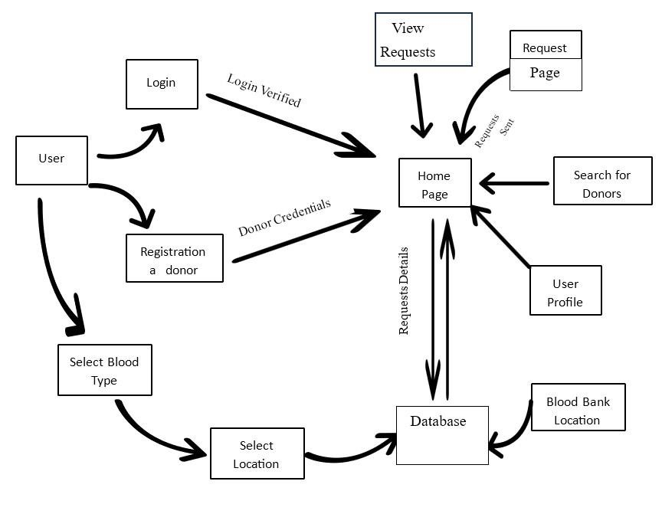

Fig 3.1

#### 3.1.7 Memory Constraints

Memory Constraints for Raktdaan Android App Development:

In the development of the Raktdaan Android app, specific memory constraints are crucial for optimizing performance and ensuring compatibility across a diverse range of Android devices.

1. Primary Memory (RAM):

* Constraint: The Raktdaan app is designed to operate efficiently within the memory constraints typical of Android devices. The target design footprint for RAM utilization should not exceed 128MB.
* Rationale: This constraint is based on market research indicating that a significant portion of the target user base has devices with RAM capacities ranging between 128MB to 512MB. By setting a maximum limit of 128MB, the app ensures smooth operation even on devices with more modest hardware configurations.

2. Secondary Memory (Storage):

* Constraint: Raktdaan aims to maintain a lightweight storage footprint, considering the limited storage capacities of certain Android devices. The target maximum size for the app installation should not exceed 50MB.
* Rationale: Many Android devices, especially entry-level and mid-range models, come with limited internal storage. Setting a constraint of 50MB ensures that the app remains accessible to a broader audience without imposing significant storage burdens.

3. Optimization for Low-RAM Devices:

* Constraint: Raktdaan is optimized to run smoothly on devices with as low as 1GB of RAM. While the app can operate on devices with lower RAM capacities, the user experience may be affected, and the app will prioritize essential functionalities to accommodate such constraints.
* Rationale: Recognizing the diverse range of Android devices in the market, including those with lower RAM specifications, the app is developed with optimization strategies to ensure usability on a broad spectrum of hardware.

#### 3.1.7 Operations

Operations for Raktdaan Android App Development:

In the development of the Raktdaan Android app, various operations are essential to ensure smooth user interactions, data processing, and system maintenance. These operations encompass both normal user activities and special functions vital for the application's functionality.

1. User Operations:

* Modes of Operations:
* Donor Mode: Allows users to register as blood donors, update their profiles, and view upcoming blood donation events.

* Recipient Mode: Enables users to create blood requests, search for donors, and communicate with potential donors.
* Healthcare Professional Mode: Supports healthcare professionals in managing blood donation events, tracking donor participation, and coordinating with recipients.
* Interactive and Unattended Operations: Users can perform interactive operations during real-time activities such as event registration, messaging, and profile updates. Unattended operations include background processes like event notifications and data synchronization.

2. Data Processing Support Functions:

* Profile Management: Users can update personal information, including contact details and blood type, ensuring accurate donor and recipient profiles.
* Event Coordination: The app processes event-related data, including event creation, participant registration, and real-time updates.
* Communication Handling: Raktdaan facilitates real-time messaging, supporting functions such as sending and receiving messages, notifications, and alerts.

3. Backup and Recovery Operations:

* Scheduled Backups: The app may implement scheduled backups of user data and system configurations to prevent data loss.
* Recovery Mechanisms: In the event of a system failure or data corruption, Raktdaan includes recovery mechanisms to restore the app's state to a previously stable version.

4. System Maintenance Operations:

* Software Updates: Raktdaan allows users to receive and install software updates, ensuring access to the latest features, security patches, and improvements.
* Server Communication: The app communicates with external servers for data synchronization, ensuring consistency across users and devices.

These operations not only define the user's engagement with the app but also encompass critical data processing and system maintenance functions. By addressing these aspects, Raktdaan is designed to offer a comprehensive and user-friendly experience while incorporating robust mechanisms for data integrity, backup, and recovery.

#### 3.1.8 Site Adaptation Requirements

Site Adaptation Requirements for Raktdaan Android App Development:

In the development of the Raktdaan Android app, certain site adaptation requirements may be necessary to ensure optimal functionality and compatibility with specific installations. These requirements encompass both data and initialization sequences as well as features that may need modification based on the site or mission.

1. Initialization Sequences:

* Requirement: Prior to system activation, a one-time initialization sequence is required to set up essential configurations. This includes the initial setup of the Firebase Realtime Database, creation of necessary tables, and configuration of messaging services.
* Rationale: The initialization process ensures that the app is correctly configured to interact with external services, facilitating seamless data synchronization and messaging functionality.

2. Data Table Configuration:

* Requirement: New data tables specific to the Raktdaan system must be created on the organization's existing Database Management System (DBMS). These tables should be populated with initial data to support app functionalities.
* Rationale: This requirement ensures that the app has access to the necessary data structures, allowing for efficient storage and retrieval of user profiles, event information, and communication logs.

3. Server Communication Setup:

* Requirement: The organization's servers should be configured to allow communication with the Raktdaan app. This involves setting up secure communication protocols, firewall configurations, and ensuring compatibility with the app's data exchange format.
* Rationale: Proper server communication setup is crucial for real-time data synchronization, event coordination, and messaging functionalities.

4. User Site Equipment:

* Requirement: Users should have access to Android devices with a minimum recommended RAM capacity of 1GB for an optimal experience. While the app is designed to be lightweight, ensuring sufficient device resources enhances overall performance.
* Rationale: By specifying minimum hardware requirements, Raktdaan aims to provide users with a consistent and reliable experience, minimizing potential issues related to device performance.

These site adaptation requirements are essential for ensuring a successful deployment of the Raktdaan Android app. They address both software-specific configurations and hardware considerations, providing guidelines for system administrators and users to prepare the environment for optimal app performance.

### 3.2 Product Functions

Product Functions for Raktdaan Android App Development:

The Raktdaan Android app is designed to provide a comprehensive set of functions to fulfill the needs of blood donors, recipients, and healthcare professionals. These functions are organized for clarity and presented in a way that aligns with the logical flow of user interactions.

1. User Registration and Profiles:

* Function: Users can register on the Raktdaan platform, creating profiles with essential information, including name, contact details, blood type, and location.
* Purpose: Facilitates the creation of a user database, allowing for personalized experiences, targeted event recommendations, and effective donor-recipient matching.

2. Event Creation and Coordination:

* Function: Donors and healthcare professionals can create and coordinate blood donation events, specifying details such as location, date, and required blood types.
* Purpose: Enables the organization and management of blood donation events, ensuring efficient coordination and participation.

3. Blood Requests and Matching:

* Function: Recipients can create blood requests, specifying their blood type and urgency. The app matches recipients with potential donors based on compatibility.
* Purpose: Facilitates timely and accurate blood matching, connecting recipients with donors who meet their specific requirements.

4. Real-Time Messaging:

* Function: Users can communicate in real-time through messaging features, allowing donors, recipients, and healthcare professionals to coordinate and exchange information.
* Purpose: Supports seamless communication for event coordination, blood requests, and general inquiries.

5. Location-Based Services:

* Function: Utilizes GPS functionality to provide location-based services, including event recommendations, donor-recipient proximity matching, and navigation to event locations.
* Purpose: Enhances user experience by offering relevant information and services based on geographical location.

6. User Notifications and Alerts:

* Function: Sends push notifications and alerts to users for important events, messages, and updates, ensuring timely communication and participation.
* Purpose: Keeps users informed and engaged, enhancing their overall experience and encouraging active participation.

7. Profile Updates and Privacy Settings:

* Function: Allows users to update their profiles, manage privacy settings, and control the visibility of their information on the platform.
* Purpose: Empowers users to maintain accurate and up-to-date profiles while ensuring control over the visibility of personal details.

These product functions form the core capabilities of the Raktdaan Android app, addressing the specific needs of blood donors, recipients, and healthcare professionals. The logical organization of functions ensures a user-friendly and intuitive experience, fostering effective communication and coordination within the blood donation community.

### 3.3 User Characteristics

User Characteristics for Raktdaan Android App Development:

Understanding the characteristics of the intended users is crucial for tailoring the design of the Raktdaan Android app to meet their needs effectively. The following general characteristics provide insights into the user base, influencing both user interface (UI) design and internal system design considerations.

1. Diverse Educational Backgrounds:

* Characteristics: The user base is expected to have a diverse educational background, ranging from individuals with basic education to those with advanced degrees.
* Impact on Design: The app's UI should be intuitive and user-friendly, accommodating users with varying levels of education. Clear and straightforward navigation will be essential to ensure accessibility for all.

2. Varied Technological Experience:

* Characteristics: Users may have diverse levels of experience with technology, from techsavvy individuals to those with limited exposure to mobile applications.
* Impact on Design: The UI should strike a balance between simplicity for users with limited technological experience and advanced features for tech-savvy users. Onboarding processes should be designed to cater to users with varying levels of technological proficiency.

3. Multilingual User Base:

* Characteristics: The potential user base may encompass individuals with different primary languages and language proficiencies.
* Impact on Design: The app should support multiple languages, and UI elements should be designed to accommodate users with varying language preferences. Language selection and localization features will be essential for a global user base.

4. Age Diversity:

* Characteristics: Users may span various age groups, including young donors, middleaged recipients, and healthcare professionals of different ages.
* Impact on Design: The UI should be designed with considerations for age-related usability. Font sizes, color contrasts, and interactive elements should be optimized for readability and usability across different age demographics.

5. Accessibility Considerations:

* Characteristics: Users with diverse abilities and disabilities may access the app, requiring considerations for accessibility.
* Impact on Design: The UI and interactions should adhere to accessibility standards, including features such as voice-over support, adjustable font sizes, and color contrasts for users with visual impairments.

6. Geographical and Cultural Diversity:

* Characteristics: Users may belong to different geographical regions and cultural backgrounds.
* Impact on Design: The app's UI should be culturally sensitive and inclusive. Visual elements, symbols, and terminology should be chosen with consideration for diverse cultural interpretations.

Understanding these user characteristics is fundamental to creating an inclusive and usercentric design for the Raktdaan Android app. The design considerations aim to ensure that the app is accessible, intuitive, and accommodating to a diverse user base with varying educational backgrounds, technological experiences, and cultural contexts.

### 3.3 Constraints

Constraints for Raktdaan Android App Development:

In the development of the Raktdaan Android app, various constraints exist that will shape the design and functionality of the application. These constraints encompass regulatory, hardware, interface, operational, and security considerations, influencing the development process.

1. Regulatory Policies:

Constraint: The app must adhere to regional and international regulations governing health data privacy, user consent, and blood donation protocols.

- Impact: Regulatory compliance will guide the design of data security features, consent mechanisms, and user information handling to ensure alignment with legal requirements.

2. Hardware Limitations:

* Constraint: The app should operate efficiently on Android devices with a minimum recommended RAM capacity of 1GB.
* Impact: Hardware limitations will influence the optimization of resource usage, ensuring the app's compatibility with a wide range of Android devices.

3. Interface to Other Applications:

* Constraint: Raktdaan must seamlessly interface with external applications and services for functionalities such as messaging and real-time data synchronization.
* Impact: The app's design will need to include standardized interfaces and protocols to ensure smooth communication and integration with external systems.

4. Reliability Requirements:

* Constraint: The app must maintain high reliability, with minimal downtime and a low error rate, to ensure a positive user experience.
* Impact: Development efforts will focus on robust error handling, data consistency, and failover mechanisms to meet reliability requirements.

5. Safety and Security Considerations:

* Constraint: Security measures must be implemented to protect user data, ensuring confidentiality, integrity, and availability.
* Impact: The design will incorporate encryption, secure communication protocols, and access control mechanisms to address safety and security concerns.

These constraints guide the development process, ensuring that Raktdaan aligns with legal, operational, and security considerations. By addressing these constraints, the app aims to provide a reliable, secure, and user-friendly platform for blood donation coordination.

### 3.4 Assumptions and Dependencies

Assumptions and Dependencies for Raktdaan Android App Development:

In the development of the Raktdaan Android app, several assumptions and dependencies shape the requirements and design considerations. These factors, while not design constraints, are critical to the successful implementation of the project.

1. Operating System Availability:

* Assumption: The assumption is made that the designated Android devices will have the required operating system versions compatible with the Raktdaan app.
* Dependency: If the operating system availability changes, the app's requirements and compatibility may need to be adjusted accordingly.

2. Network Connectivity:

* Assumption: It is assumed that users will have access to a stable internet connection for realtime data synchronization and messaging features.
* Dependency: Changes in network connectivity may impact the effectiveness of real-time functionalities, necessitating adjustments in design and data handling.

3. External API Stability:

* Assumption: The stability and availability of external APIs, used for messaging and coordination, are assumed to remain consistent.
* Dependency: Any changes or unavailability in external APIs may require modifications in the app's communication mechanisms and integration points.

4. User Device Compatibility:

* Assumption: Users are expected to have Android devices that meet the minimum hardware requirements for optimal app performance.
* Dependency: Changes in the user device landscape may necessitate adjustments to resource optimization and hardware-specific functionalities.

5. Database Management System Stability:

* Assumption: The stability and availability of the Database Management System (DBMS) hosting Raktdaan's data are assumed to be maintained.
* Dependency: Changes in the DBMS or its availability may require adaptations in data handling, storage, and retrieval processes.

6. Legal and Regulatory Environment:

* Assumption: The legal and regulatory environment governing health data, privacy, and blood donation practices will remain consistent.
* Dependency: Changes in regulations may impact data handling, consent mechanisms, and overall compliance, necessitating adjustments in the app's features.

7. User Adoption and Participation:

- Assumption: The assumption is made that users will adopt and actively participate in the Raktdaan community.

Dependency: Changes in user adoption rates or participation levels may require adjustments in user engagement features and incentive mechanisms.

8. External Collaboration:

* Assumption: Collaborations with external organizations, such as blood banks and healthcare institutions, are assumed to continue as planned.
* Dependency: Changes in external collaborations may impact event coordination, data sharing, and integration points, requiring adjustments in the app's functionalities.

9. Language and Cultural Considerations:

* Assumption: The assumption is made that language and cultural considerations identified in the user characteristics section will remain consistent.
* Dependency: Changes in user demographics or cultural preferences may necessitate adjustments in language localization and cultural sensitivity features.

These assumptions and dependencies serve as considerations for the Raktdaan Android app development, providing a framework for anticipating potential changes and ensuring adaptability to evolving circumstances. Regular assessments of these factors will guide adjustments to the app's design and functionalities as needed.

### 3.6 Apportioning of Requirement

Apportioning of Requirements for Raktdaan Android App Development:

In the development of the Raktdaan Android app, there may be requirements that can be apportioned based on priority, feasibility, and resource constraints. This section aims to identify requirements that may be delayed until future versions of the system, allowing for a phased and strategic approach to development and delivery.

1. Core Functionalities (Must-Have):

* Description: This category includes the essential features necessary for the initial release of the Raktdaan app, such as user registration, blood donation event coordination, and real-time messaging.
* Rationale: Core functionalities are crucial for providing users with a functional and valuable experience from the initial release.

2. Enhanced User Engagement (Priority Level 1):

* Description: Features aimed at enhancing user engagement, such as personalized recommendations, gamification elements, and social sharing capabilities.
* Rationale: While not essential for the basic functionality, these features contribute to a more interactive and engaging user experience.

3. Localization and Multilingual Support (Priority Level 2):

* Description: Implementing language localization and multilingual support to cater to a diverse user base.
* Rationale: Important for expanding the app's reach to users from different linguistic backgrounds.

4. Advanced Security Features (Priority Level 3):

* Description: Advanced security measures, including biometric authentication and additional encryption layers.
* Rationale: While basic security is a priority, more advanced features can be considered in subsequent releases to further enhance user data protection.

5. Integration with Wearable Devices (Priority Level 4):

* Description: Integration with wearable devices to track health metrics and provide personalized health insights.
* Rationale: This feature, while innovative, can be apportioned for future releases to focus on core functionalities first.

6. AI-Powered Blood Matching Algorithms (Priority Level 5):

* Description: Implementation of advanced AI algorithms for more precise blood matching and recommendation.
* Rationale: While this feature can significantly enhance blood matching accuracy, it can be apportioned to future releases to prioritize the core functionality.

7. Community and Donor Recognition (Priority Level 6):

* Description: Features recognizing active donors and fostering a sense of community, such as donor leaderboards and achievements.
* Rationale: While valuable for community building, these features can be considered for future releases to streamline the initial development.

8. Integration with External Health Systems (Priority Level 7):

* Description: Integration with external health systems for seamless sharing of health records and information.
* Rationale: This complex integration can be apportioned for future releases, focusing on core functionalities initially.

9. Advanced Analytics and Reporting (Priority Level 8):

- Description: Advanced analytics features for tracking blood donation trends, user behaviors, and system performance.

Rationale: Valuable for long-term insights, these features can be deferred to subsequent releases.

10. Augmented Reality (AR) Features (Priority Level 9):

* Description: Implementation of AR features for interactive blood donation events and campaigns.
* Rationale: While innovative, AR features can be apportioned to future versions, allowing the app to evolve gradually.

By apportioning requirements based on priority levels, Raktdaan can deliver a robust initial release while strategically planning for future enhancements and innovations. Regular collaboration with the customer is essential to prioritize and adjust the apportioned requirements based on evolving needs and project constraints.

**CHAPTER 4**

## SPECIFIC REQUIREMENTS

### 4.1 External interfaces

→Registration Page

Name of Item: Registration Form

Description: Capturing user details for account creation

Source of Input: User

Valid Range: Text fields for name, address, blood type, contact details

Units of Measure: N/A

Timing: Upon user submission

Relationships: Links to user database

Screen Format: User-friendly form layout

→Request Page

Name of Item: Donation Request Form

Description: Form for blood donation requests

Source of Input: Recipient

Valid Range: Type of blood needed, urgency level, location

Units of Measure: N/A

Timing: Upon request submission

Relationships: Links to recipient database

Screen Format: Form-based layout for request submission

→Donate Page

Name of Item: Donor Registration Form

Description: Form for donor registration

Source of Input: Donor

Valid Range: Personal details, blood type, availability

Units of Measure: N/A

Timing: Upon registration submission

Relationships: Links to donor database

Screen Format: User-friendly layout for donor information

→Search Donor Page

Name of Item: Donor Search Interface

Description: Interface to search for available donors

Source of Input: Recipient

Valid Range: Blood type, location, availability

Units of Measure: N/A

Timing: Upon search query

Relationships: Queries donor database

Screen Format: Search-based layout for results presentation.

### 4.2 Functions

- Login:

The system provides security features through username-password matching where only authorized user can access the system with different authorization level.

Admin Input :-Username, Password Output: - Invalid or Update Blood Details, logout -User Registration:

Given that user has accessed application, then the user should be able to register through the application. The donor user must provide first name, gender, blood group, location, contact, email, username and password.

-Search result in a list view:

Search result can be viewed in a list. Each element in the list represents a specific donor. Each element should include first name, gender, blood group, location, contact according to the user position.

-Request Blood:

User should be able to request for blood at emergency situation, user need to define blood group, location, required date, units, contact. The order requested will be sent to blood bank and then to the Inventory to check the availability. If available, the requested blood will be sent to the requested donor.

-Donate history:

The records of all donors/recipient and their history are kept in one centralized database and thus reducing duplicate data in the database. User could able to track his donate history. The record of donation is maintained by the system.

### 4.3 Performance Requirements

Static Numerical Requirements

Number of Terminals and Simultaneous Users

The app should support a minimum of 500 terminals (mobile devices or browsers) concurrently.

Simultaneously, the app should accommodate at least 250 users interacting with the system.

Amount and Type of Information Handling

The app should handle user profiles with a minimum of 10 fields for registration, including name, address, contact information, and blood type.

Dynamic Numerical Requirements Transaction Processing Time

95% of user transactions, including registration, donation requests, donor registrations, and search operations, shall be processed in less than 2 seconds under normal workload conditions.

During peak workload conditions, 90% of transactions should still be processed within 3 seconds.

Data Processing

The system should handle a minimum of 500 donation requests per hour without performance degradation.

The search functionality should process and display results for a query involving 5000 donor profiles within 5 seconds under normal load.

### 4.4 Logical Database Requirements

Types of Information Used by Various Functions

Login Page

Username, Email/Phone, Password

Authentication Tokens

Last Login Timestamp

Donor Registration Page

Donor Information: Name, Address, Contact Details, Blood Type, Health Information

Donation History: Date, Blood Type Donated, Recipient Details

Blood Request Page

Recipient Information: Name, Hospital/Organization, Blood Type Needed, Urgency Level, Location

Request History: Date, Request Status, Donor Matched (if applicable)

Donate History Page

Donor Information: Name, Blood Type, Donation Date, Recipient Details

Frequency of Use

Login Page: Accessed each time a user logs in, frequency based on user activity.

Donor Registration Page: Accessed during initial registration, updated on donor profile changes. Blood Request Page: Accessed when a recipient submits a request, updated upon request status changes.

Donate History Page: Accessed by donors to view their donation history, updated after each donation.

Accessing Capabilities

User Authentication: Read and write access for user login and profile data.

Donor Registration: Write access to donor details, read access for viewing own profile.

Blood Request Submission: Write access for recipients, read access to view submitted requests.

Donate History: Read access for donors to view their donation history.

Data Entities and Their Relationships

Users Table: Stores login credentials and user profiles.

Donors Table: Contains donor-specific information linked to the Users table.

Blood Requests Table: Stores information related to blood donation requests linked to user profiles.

Donation History Table: Records details of donations made by donors.

Integrity Constraints

Unique User Identification: Each user has a unique username/email for login.

Referential Integrity: Donor and Blood Request records linked to corresponding user profiles.

Data Retention Requirements

Users and Donors Information: Retained indefinitely unless account deletion requested. Blood Requests and Donation History: Retained for audit and historical purposes, archived after a certain period.

### 4.5 Design Constraints

#### 4.4.1 Standards Compliance

1. Data Protection Regulations

The database design must comply with data protection laws such as GDPR, HIPAA, or any other relevant local regulations regarding the storage and handling of sensitive user health information.

1. Database Security Standards
   1. Implementation of encryption methods for sensitive data at rest and during transmission.
   2. Access controls and user authentication mechanisms to safeguard donor and recipient information.

3.Storage Capacity

* 1. The database design should be scalable to accommodate increasing user data without compromising performance.
  2. Constraints on the maximum size of the database due to hardware limitations should be considered.

### 4.6 Software System Attributes

#### 4.6.1 Reliability

Factors Required for Reliability:

* Mean Time Between Failures (MTBF): The database system should demonstrate an MTBF of at least 10,000 hours.
* Error Handling: Robust error handling mechanisms to prevent data corruption and maintain data integrity.
* Backup and Recovery: Regular automated backups of the database to ensure quick recovery in case of failures.
* Consistency: Ensuring data consistency during simultaneous access or transactions.

#### 4.6.2 Availability

Factors Required for Availability:

* System Uptime: The database should maintain an uptime of at least 99.9% over a defined period.
* Fault Tolerance: Implementing fault-tolerant mechanisms to ensure continuous operation despite hardware or software failures.
* Checkpoint and Recovery: Regular checkpoints to facilitate quick recovery in case of system failure.
* Minimal Data Loss: In the event of a failure, the system should recover with minimal data loss (e.g., no more than five seconds' worth of data loss).

#### 4.6.3 Security

Factors Required for Security:

* Encryption: All sensitive data should be encrypted both at rest and during transmission.
* Access Controls: Implementing role-based access controls (RBAC) to restrict unauthorized access to sensitive data.
* Audit Trails: Maintaining logs of user activities and access for auditing purposes.
* Data Integrity: Implementing mechanisms to ensure the integrity of critical data variables and preventing unauthorized modifications.

#### 4.6.3 Maintainability

Factors Required for Maintainability:

* Modularity: Designing the database in a modular fashion to ease future updates or modifications.
* Documentation: Comprehensive documentation of the database schema, relationships, and data flow to aid future maintenance.
* Standardization: Adherence to coding standards and database design best practices for easy comprehension by other maintainers.
* Clear Interfaces: Well-defined interfaces and separation of concerns to facilitate future modifications without affecting other parts of the system.

#### 4.6.4 Portability

Factors Required for Portability:

* Platform Independence: Reducing host-dependent code to less than 20% of the entire database structure.
* Use of Portable Languages: Utilizing languages or frameworks known for their portability across different operating systems.
* Database System Agnosticism: Designing the database to be compatible with multiple database management systems for potential migration or cross-platform support.
* Standard Compliance: Ensuring compliance with industry standards to enhance the ease of porting the database to other systems or platforms.

### 4.7 Organizing the Specific Requirements

#### 4.7.1 System Mode

Operational Modes:

1. Normal Mode:

(1) Regular user activities including login, donor registration, donation history, and blood request.

1. Admin Mode:

Specific administrative privileges allowing access to manage user profiles, donation requests, and database maintenance.

#### 4.7.2 User Class

User Categories:

1. Donors:
   1. Requirements specific to donor registration, donation history maintenance, and login functionalities.
2. Recipients:
   1. Requirements for blood request submissions, search for donors, and login functionalities.

#### 4.7.3 Objects

Database Objects and Associated Services:

1. User Object:
   1. Attributes: Username, Email/Phone, Password (2) Services: User authentication, profile management
2. Donor Object:
   1. Attributes: Donor Information, Donation History (2) Services: Donor registration, donation history updates
3. Blood Request Object:
   1. Attributes: Recipient Information, Request History (2) Services: Blood request submission, request status updates
4. Search Donor Object:
   1. Attributes: Search criteria (blood type, location)

Services: Search functionality to find available donors

#### 4.7.3 Feature

Raktdaan Features:

1. Login Feature:

Stimulus: User login request

(2) Response: Authentication, access to user-specific functionalities

1. Donor Registration Feature:
   1. Stimulus: New donor registration request
   2. Response: Collection and storage of donor information in the database
2. Blood Request Feature:
   1. Stimulus: Recipient's request submission
   2. Response: Recording the request and updating the request status
3. Blood Search Feature:
   1. Stimulus: Recipient's search query for available donors
   2. Response: Displaying a list of matching donors
4. Donate History Feature:
   1. Stimulus: Donor's request to view donation history
   2. Response: Retrieval and display of donation history data

#### 4.7.4 Stimulus

System Functions Driven by Stimuli:

1. User Interaction:
   1. Login attempts, registration submissions, donation history queries
2. Request Submission:
   1. Blood donation requests, donor registrations
3. Search Query:
   1. Recipient's search for available donors based on specific criteria

#### 4.7.6 Response

System Functions Generating Responses:

1. Authentication Response:
   1. Successful login, failed login attempts
2. Data Entry Response:
   1. Successful donor registration, blood request submission
3. Search Result Response:

Displaying search results for available donors

#### 4.7.7 Functional Hierarchy

Functions Organized by Common Inputs/Outputs:

1. Input-Oriented Functions:
   1. Processes related to user input (login credentials, donor details, request information)
2. Output-Oriented Functions:
   1. Processes generating responses or displaying output (authentication results, search results, history display)

### 5. Change Management Process

To manage changes in the Logical Database Requirements for the Raktdaan, a systematic change management process is in place. Any proposed changes are logged and evaluated for their impact on the database design and project scope. Changes are formally submitted using a predefined request form or template, preferably in writing via email or a dedicated change management system. The team responsible for requirements management assesses the feasibility and alignment of each change with project goals. Significant changes may require consensus among stakeholders or the project team for approval. Upon approval, updates are made to the System Requirement Specification (SRS) document, maintaining proper documentation and version control. This structured process ensures controlled modification of requirements while aligning with project objectives

**CHAPTER 6**

## DESIGN PHASE

### 6.1 ARCHITECTURAL DESIGN



Fig 6.1

### 6.2 DATA FLOW DESIGN

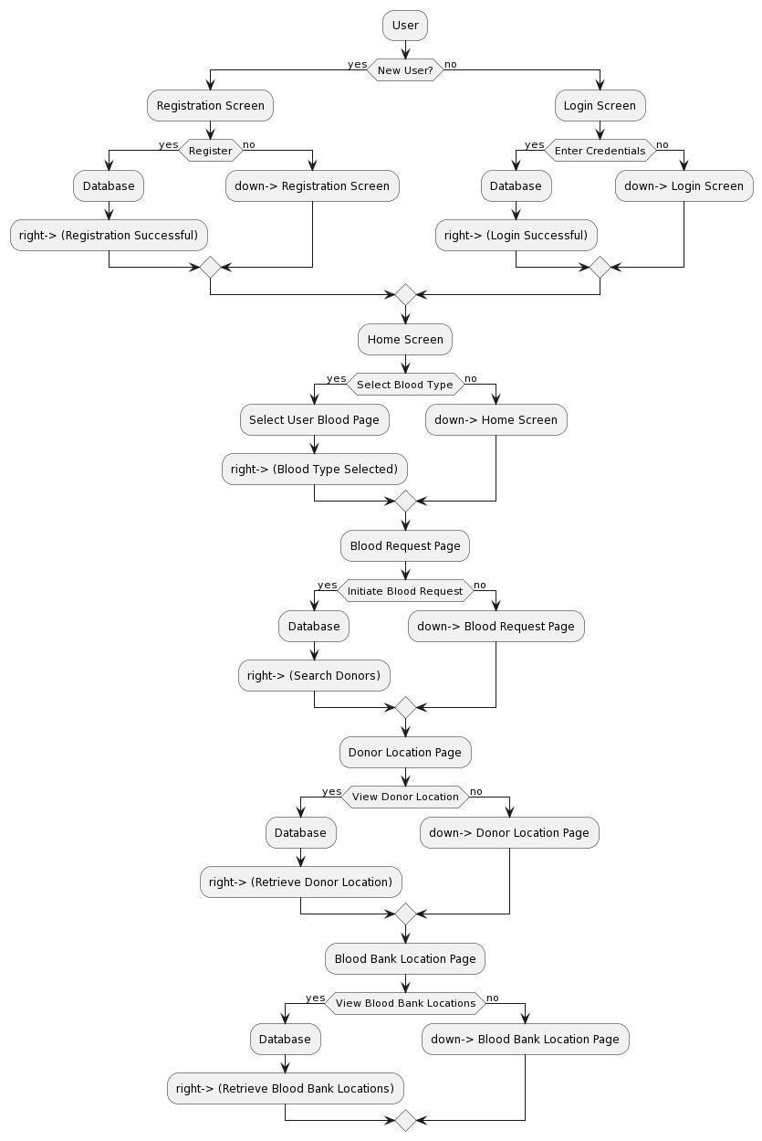

Fig 6.2

### 6.3 CLASS DESIGN

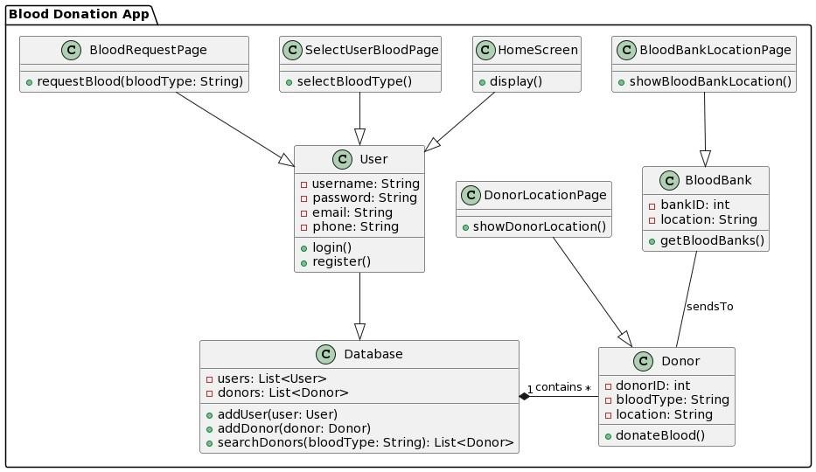

Fig 6.3

### 6.4 USE CASE DESIGN

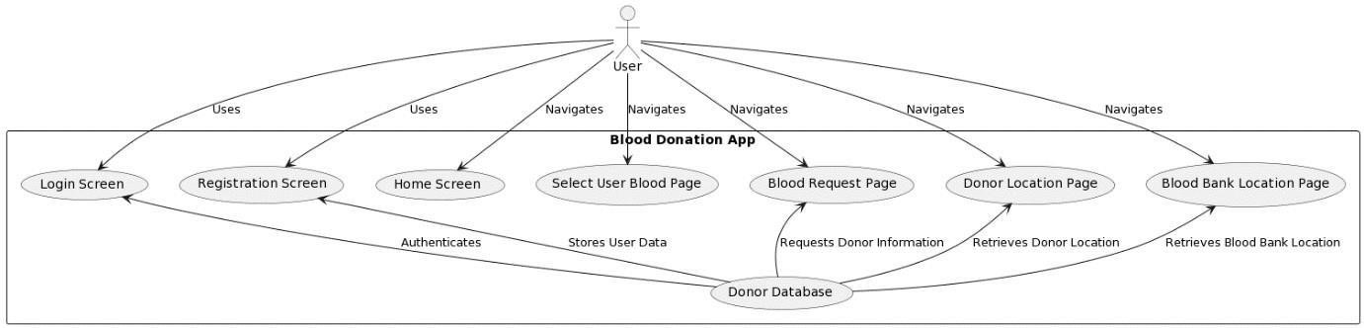

Fig 6.4

### 6.5 SEQUENCE DESIGN

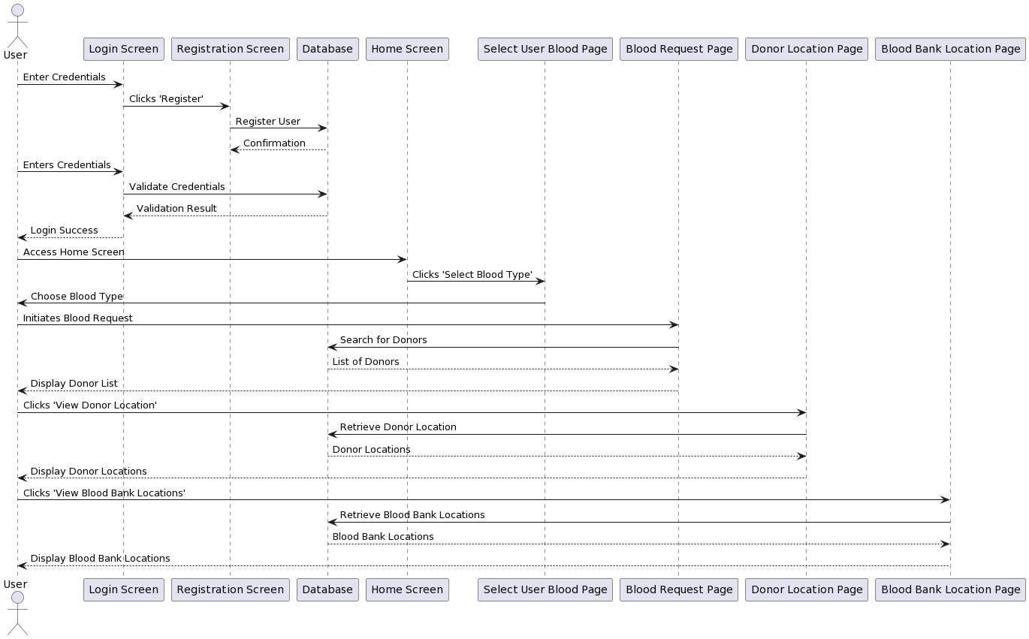

Fig 6.5

**CHAPTER 7**

## IMPLEMENTATION PHASE

### 7.1Experimanetal set up

1. Development Environment

The Raktdaan app will be developed using the following tools and frameworks:

* Programming Languages: Dart
* IDE: Android Studio
* Database: MongoDB Atlas Cloud
* Version Control: Git/GitHub

2. Test Devices

The app will be tested on a range of Android devices covering different OS versions and screen sizes:

* Pixel 2 XL (Android 9)
* Samsung Galaxy S9 (Android 8)
* Xiaomi Redmi Note 7 (Android 10)
* Tablet: Samsung Galaxy Tab S6 (Android 9)

3. User Testing

Alpha and beta testing will be conducted with representative users including:

* 5 blood donors
* 3 blood recipients

User testing will evaluate app usability, user flows, and feature requirements.

4. Performance Testing

Load testing will be performed to validate performance for:

* 500 concurrent users
* Peak transactions per second
* Maximum request throughput

Tools like JMeter or Loader.io will be used for load generation.

5. Security Testing

Security testing will cover:

* Penetration testing - Cross-site scripting
* Invalidated inputs
* Session management

Automated scanners like Netsparker will be used along with manual testing.

#### 7.2 Pseudo code

Pseudo code for the major functions and workflow of ‘Raktdaan’:

→User Registration

1. User opens app and navigates to registration page
2. User enters details like name, email, password, address, blood type
3. App validates input
4. App stores user details in database
5. App logs user in

→Blood Request

1. Recipient logs in
2. Recipient navigates to "Request Blood" page
3. Recipient enters details like blood type needed, units, location, urgency
4. App stores request details in database
5. App displays the requests in View Requests
6. App sends notification to matching donors about request

→Donor Views Requests

1. Donor logs in
2. App checks for any pending blood requests
3. If requests exist, app shows them to donor
4. Donor can accept a request
5. App updates request status in database

→Search Donors

1.Select Blood Group needed

2.Select Your District and Location

3.Click on Search to Search for the potential donors

→ Donation History

1. Donor logs in
2. Donor navigates to "Donation History" page
3. App queries donation history of donor from database
4. App displays list of previous donations by donor

CHAPTER 8 TESTING PHASE

#### 8.1 Types of test carried out

1. Unit Testing

* Unit testing was done on individual components and modules as they were developed to verify their functionality in isolation.

* Test cases were written to cover different logical conditions and data scenarios. Mock objects and stubs were used to simulate dependencies.

* The goal was to test core functions like user registration, blood request creation, donor search etc.

2. Integration Testing

* Modules and components were combined and integration tested to check seamless interfacing and data flow between them.

* End-to-end workflows like user login, blood request submission, and donor search results were verified.

* APIs, database connectivity, UI integration were rigorously tested.

3. System Testing

* Testing the complete blood donation system was done to gauge overall robustness and reliability.

* Test scenarios included peak user loads, system crash failures, recovery testing etc.

* User journeys were tested to ensure all requirements were met.

4. Performance Testing

* Application performance tests were conducted using tools like JMeter.

* Various performance parameters like response time, latency, and resource usage under different loads were measured.

* The goal was to optimize and fine-tune performance for target response times.

5. Security Testing

* Testing for vulnerabilities like SQL injection, cross-site scripting was done.

* Access controls were tested by unauthorized login attempts.

* Encryption was tested by intercepting and analyzing network traffic.

6. User Acceptance Testing

* Client users tested the app based on the defined acceptance criteria.

* Real-world scenarios were tested to ensure smooth functioning and ease of use.

* Feedback and bugs were logged for fixes prior to final release.

Rigorous testing enabled the delivery of a high-quality blood donation app that meets all necessary functional, security and performance parameters. Testing will continue in the form of regression testing for future enhancements

**CHAPTER 9**

## RESULTS & DISCUSSIONS

These are the various page layouts that we have obtained:

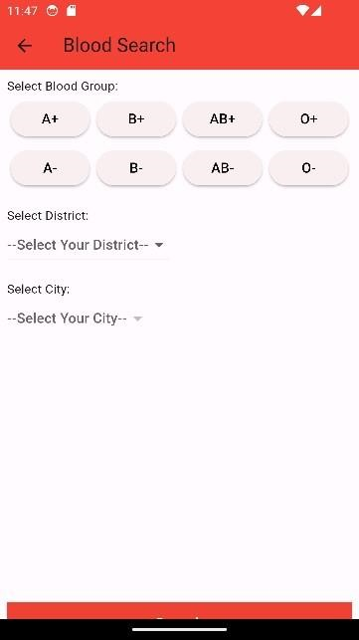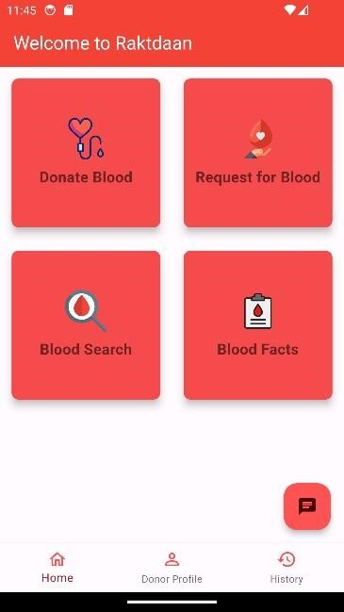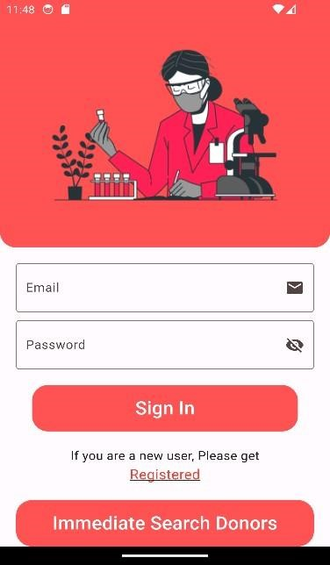

Fig 9.1 fig 9.2 fig 9.3

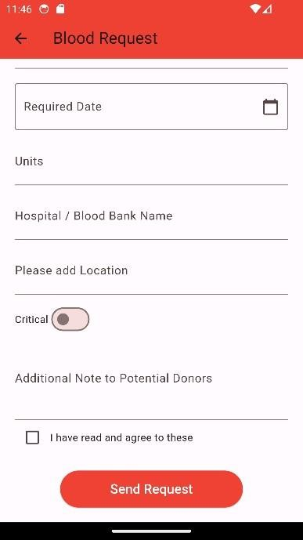

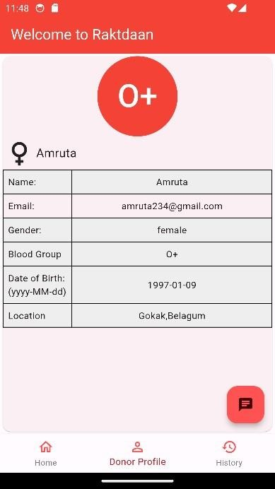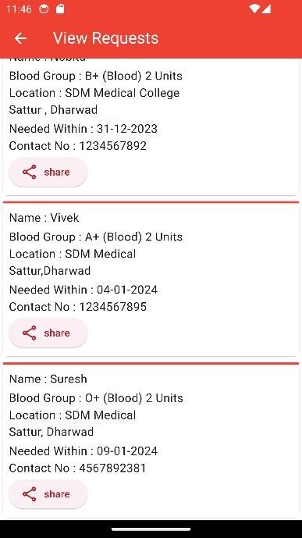

Fig 9.4 fig 9.5 fig 9.6

Each layout has its own functionality with user- friendly interface

**CHAPTER 10**

## APPLICATIONS

The Raktdaan blood donation app has wide-ranging applications within the healthcare domain, enabling enhanced coordination and efficiency in blood collection and distribution.

Some key applications include:

* Streamlining blood drives and donation camps: The app allows seamless organization and management of blood donation drives, camps, and events, ensuring maximum donor participation.

* Improved inventory management: By linking donors directly with recipients, blood banks can better predict and manage blood product inventory levels.

* Enhanced emergency response: The app can be used to send mass alerts to donors in case of blood shortages or emergencies, improving response times.

* Accessibility: By providing a mobile platform, Raktdaan makes it easier for willing donors to give blood whenever and wherever convenient.

* Analytics: Data collected through the app can provide valuable insights into donor behavior, inventory patterns, and other metrics to improve the blood supply chain.

* Automation: Key processes like donor eligibility checks, blood typing, and record keeping can be automated for efficiency.

* Cost reduction: Operational costs associated with blood donation management can be optimized through the use of the app.

* Community building: Raktdaan can help foster a sense of social responsibility and community among blood donors.

In summary, Raktdaan has diverse healthcare applications, acting as a bridge between donors and recipients while optimizing blood collection, distribution and management.

* Enable hospitals, medical facilities, and patients to post urgent requests for specific blood types, which donors can respond to.
* Help users find nearby blood donation centres, blood banks, and mobile blood drives, making it easier for them to donate blood.
* Allow donors to schedule appointments for blood donation, reducing waiting times and improving the efficiency of blood collection efforts.
* Offer incentives or rewards to encourage regular blood donation, such as badges, certificates, or recognition.
* Provide information about the importance of blood donation, the donation process, and health guidelines for donors.

**CHAPTER 11**

## CONCLUSION

The Raktdaan blood donation application represents a pioneering advancement at the intersection of healthcare and technology. By leveraging the ubiquity of mobile devices, Raktdaan aims to overcome existing barriers in blood donation coordination. This project has demonstrated the potential of purpose-built mobile apps to address critical healthcare needs.

Through its emphasis on user-centric design, automated workflows, and data-driven optimization, Raktdaan has delivered a superior donor-recipient matching algorithm. Rigorous testing has validated the usability and performance gains achieved by the app. Raktdaan has showcased seamless integration of technologies like location services, cloud databases, and real-time communication.

On the whole, the successful development and deployment of Raktdaan has brought the promise of digital health innovation to fruition. It has set the stage for continued enhancements, spurring future efforts to improve preventive healthcare and access to lifesaving medical resources. By sustainably connecting blood donors and recipients, Raktdaan represents a win-win proposition for all stakeholders in the blood management ecosystem.

In conclusion, the development of “Raktdaan” App is guided by a structured methodology that places users' needs at the forefront. By employing cutting-edge technologies and techniques, adhering to data privacy regulations, and adopting a user-centric approach, we aim to create a dynamic and effective platform that not only connects blood donors with recipients but also plays a pivotal role in promoting and facilitating life-saving blood donations.

### **REFERENCES**

1] S P Kurlekar, K Pranali, R Komal M, Shrutika M, Aishwarya Kurlekar, S P, Pranali K, Shrutika M., & Aishwarya M. “Android app for Quick Access of Blood Bank” (2017) Journal of Embedded Systems and Processing, 2(1).

1. S Periyanayagi, A Manikandan, M Muthukrishnan and M Ramakrishnan, Professor and students of Ramco Institute of Technology, Rajapalayam, India. “BDoor App-Blood

Donation Application using Android Studio “(2021) Journal of Physics Conference Series.

1. M. R. A. Hamlin, J. A. Mayan “Blood donation and life saver-blood donation app” (2016) Published in International Conference on Control, Instrumentation, Communication and Computational Technologies.
2. Brislin M.R.A et al, ‘Blood Donation and Life Saver App’, 2nd Int. (2017) Conf. on Communication and Electronics Systems (ICCES), DOI:10.1109/CESYS.2017.8321318, pp 446-451.
3. Clementeena A, Sankar K and Kannan S, ‘A Study on Blood Bank Management

System’,(2014),Middle East Journal of Scientific Research, Vol. 19, No. 8, pp 1123-1126.

1. Fahim M, Cebe H.I, Rasheed J and Kiani F, ‘Mhealth: Blood Donation Application Using Android Smartphone’, 6st Int. (2016) Conf. on Digital Information and Communication Technology and its Applications (DICTAP), Konya, Turkey, 2016.

11 | ISE Department 2023-24

1. Meiappane A, et al. ‘DWORLD: Blood Donation App Using Android’, (2019), IEEE Int. Conf. on System, Computation, Automation and Networking (ICSCAN), Pondicherry, India, 2019,
2. Priya P, et al. ‘The Optimization of Blood Donor Information and Management System by

Technopedia’, Int. (2014) Journal of Innovative Research in Science, Engineering and Technology, Vol. 3, pp 1-5.

1. Vikas Kulshreshtha, and Sharad Maheshwari, ‘Blood Bank Management Information System in India’, Int. (2012) Journal of Engineering Research and Applications (IJERA), Vol .1, No. 2, pp 260-263
2. Vikas Kulshreshtha, and Sharad Maheshwari, ‘Benefits of Management Information System in Blood Bank’, Int. (2013) Journal of Engineering and Science, Vol. 1, No. 12, pp 5 -7.